Apostles and Bishops Curriculum Outline
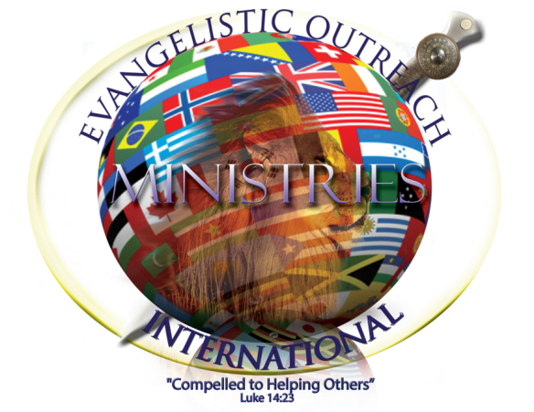
 | 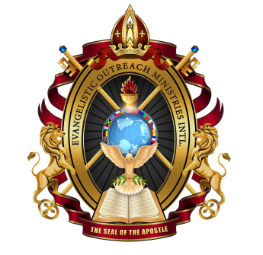 |  | 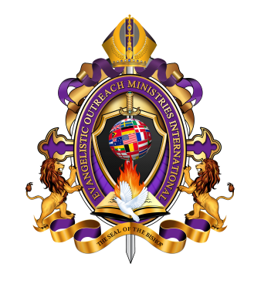
Seal of EOM Chief Apostle | Seal of EOM Apostles | EOM Presiding Bishop Seal | Seal of EOM Bishops

Welcome to EOM Official Training/Catechism
For Apostle and Bishops

I greet you Apostles and Bishops in the name of our Lord and Savior Jesus Christ. I am Apostle Lawrence C Dunbar, EOM Chief Apostle. On behalf of EOM General Board of Directors, leaders and I welcome to our official training. I want to thank you for the opportunity to serve you and the people you will be serving. We are honored to have you as our first scholars to EOM official training/ catechism class for Apostles and Bishops. I give honor and thanks to the Lord for bring us this far. As holy priests of God, we are striving for spiritual excellence in everything we do for our heavenly Father. Please take this opportunity to learn by increasing your knowledge in the word of God. We will do our best to teach you by Gods word of knowledge and word of wisdom. Our teachers do not claim to know everything; therefore be patient as we seek the Lord about things we do not know. We can assure you that if you listen, learn, and do the required assignments that you will be ready for your assigned office or position.

Please go to www.eomuniversity.com and register for training. This training is by invitation only; therefore, it is imperative that we know who is in our training. As your official consecrating and ordaining authority, we are mandated by God to make you accountable and worthy for His holy priesthood. Your information will help us to keep track of you, your progress and will only be used for administrative purposes. Once you have registered, we will email or text a special link for training; please do share this link with anyone.

February 2018 Classes
Class 1: Introduction Part-1  Date: February 5, 2018 at 8-9:30pm EST  Reading Assignment: check course website  Teacher: Apostle Lawrence C. Dunbar | Class 2: Introduction Part-2  Date: February 12, 2018 at 8-9:30pm EST  Reading Assignment: check course website Teacher: Apostle Lawrence C. Dunbar
Class 3: Priestly Garments Part-1 (1½ hours)  Date: February 19, 2018 at 8-9:30pm EST  Reading Assignment: check course website  Teacher: Apostle Maurice Halstead | Class 4: Priestly Garments Part-2 (1½ hours)  Date: February 26, 2018 at 8-9:30pm EST  Reading Assignment: check course website  Teacher: Apostle Maurice Halstead

March 2018 Classes
Class 3: EOM Holy Convocation (1½ hours)  Date: March 5, 2018 at 8-9:30pm EST  Assignments: check course website  Teacher: Apostle Lawrence C. Dunbar | Class 4: Role of Apostle Part-1 (1½ hours)  Date: March 12, 2018 at 8-9:30pm EST  Assignments: check course website  Teacher: Apostle Lawrence C. Dunbar
Class 5: Role of Apostle Part-2 (1½ hours)  Date: March 19, 2018 at 8-9:30pm EST  Assignments: check course website  Teacher: Apostle Lawrence C. Dunbar | Class 6: Role of Bishop Part-1 (1½ hours)  Date: March 26, 2018 at 8-9:30pm EST  Assignments: check course website  Teacher: Apostle James Ferguson

April 2018 Classes
Class 7: Role of Bishop Part-2 (1½ hours)  Date: April 2, 2018 at 8-9:30pm EST  Assignments: check course website  Teacher: Apostle James Ferguson | Jesus Three Core Values  Class 8: Soul Winning Part-1 (1½ hours)  Date: April 9, 2018 at 8-9:30pm EST  Assignments: check course website  Teacher: Apostle Bernard Williams
Jesus Three Core Values  Class 16: Spiritual Warfare Part-2 (1½ hours)  Date: April 9, 2018 at 8-9:30pm EST  Assignments: check course website  Teacher: Apostle Bernard Williams | Jesus Three Core Values  Class 23: Unifying Saints Part-3 (1½ hours)  Date: April 16, 2018 at 8-9:30pm EST  Assignments: check course website  Teacher: Apostle Bernard Williams
Class 11: Marital Values (1½ hours)
Date: April 30, 2018 at 8-9:30pm EST
Assignments: check course website
Teacher: Apostle Vernon Whitaker

May 2018 Classes
Class 12: Spiritual Leadership (1½ hours)  Date: May 7, 2018 at 8-9:30pm EST  Assignments: check course website  Teacher: Apostle Robert Currie | Class 13: Embracing Women In Ministry (1½ hours)  Date: May 14, 2018 at 8-9:30pm EST  Assignments: check course website  Teacher: Apostle James Ferguson
Class 14: Spirit Of Excellence In Leadership  Date: May 21, 2018 at 8-9:30pm EST  Assignments: check course website  Teacher: Apostle Maurice Halstead | Class 15: God’s Relationship with You  Date: May 28, 2018 at 8-9:30pm EST  Assignments: check course website  Teacher: Apostle Vernon Whitaker
June 2018 Classes
Class 16: God’s Relationship with your Family  Date: June 4, 2018 at 8-9:30pm EST  Assignments: check course website  Teacher: Bishop Charles Sawyer | Class 17: God’s Relationship with You in the Church Body  Date: June 11, 2018 at 8-9:30pm EST  Assignments: check course website  Teacher: Apostle Robert Currie
EOM 4th Holy Convocation June 18-25, 2018

July 2018 Classes
Class 18: EOM Strategy of 12  Date: July 2, 2018 at 8-9:30pm EST  Assignments: check course website  Teacher: Apostle James Ferguson | Class 19: EOM Blueprint  Date: July 9, 2018 at 8-9:30pm EST  Assignments: check course website  Teacher: Apostle James Ferguson
Class 20: Money In Ministry  Date: July 16, 2018 at 8-9:30pm EST  Assignments: check course website  Teacher: Bishop Charles Sawyer | Class 21: Man/Woman Authority/Power (Part-1)  Date: July 16, 2018 at 8-9:30pm EST  Assignments: check course website  Teacher: Apostle Lawrence C Dunbar
Class 22: Man/Woman Authority/Power (Part-2)
Date: July 30, 2018 at 8-9:30pm EST
Assignments: check course website
Teacher: Apostle Maurice Halstead

August 2018 Classes
Class 23: Man/Woman Authority/Power (Part-3)  Date: August 6, 2018 at 8-9:30pm EST  Assignments: check course website  Teacher: Apostle Bernard Williams | Class 24: Man/Woman Authority/Power (Part-4)  Date: August 13, 2018 at 8-9:30pm EST  Assignments: check course website  Teacher: Apostle Maurice Halstead
Class 25: God Divine Marriage  Date: August 20, 2018 at 8-9:30pm EST  Assignments: check course website  Teacher: Apostles Bernard Williams | Class 26: Understanding Divorce  Date: August 27, 2018 at 8-9:30pm EST  Assignments: check course website  Teacher: Apostle Vernon Whitaker

September 2018 Classes
Class 27: Salvation For Everyone
Date: September 3, 2018 at 8-9:30pm EST
Assignments: check course website
Teacher: check course website

